**WEEK 11 ASSIGNMENT BDWUP**

**USE FILTER ROWS TRANSMISSION (CONNECT CSV FILE WITH FILTER AND MULTIPLE OUTPUTS)**

**Aim:**

To connect data from a excel file and click preview rows to verify the file is being read correctly.

**Algorithm:**

1.Start the process.

2.Create a Sales database using Excel.

3.Save the file in .xls format.

4.Open Pentaho Spoon tool for data integration.

5.Choose text input and text output for data retrieval.

6.Save the file.

7.Stop the process.

**OUTPUT:**

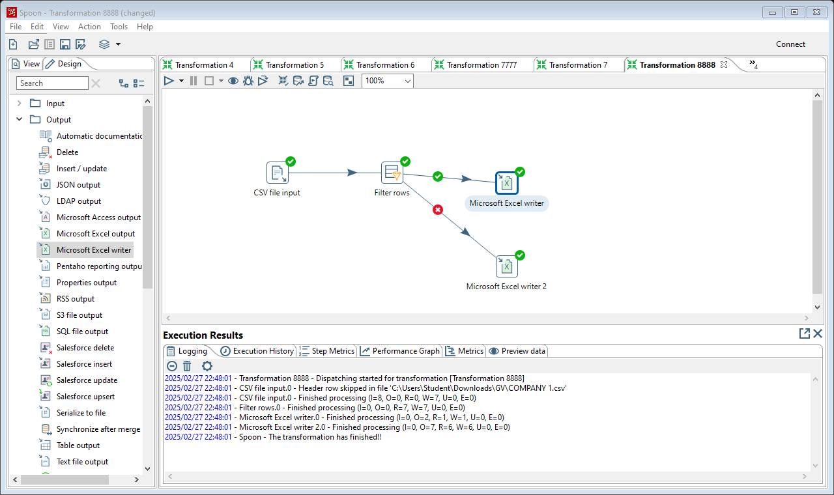

**Result :**

The above termination is executed successfully.